CHAPTER 3: Systems working together

Worksheet 3.3

Removing waste
from the blood
Answers

Removing waste from the lungs
1. The following table compares the composition of the air breathed into and out of the lungs.
Gas | Oxygen (%) | Carbon dioxide (%) | Water vapour (%) | Nitrogen (%)
Air breathed in | 21 | 0.04 | Usually <1% | 78
Air breathed out | 16 | 4 | 2  Carbon dioxide | 78
(a) Which listed gas is classified as a waste gas?
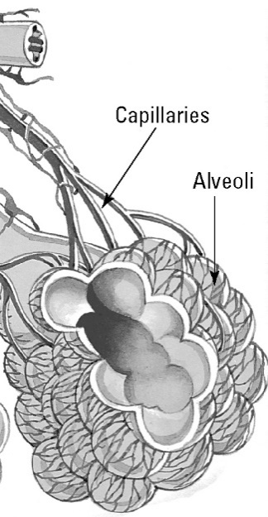 | (b) Explain why the percentage of oxygen has decreased and the percentage of carbon dioxide has increased.  Some of the oxygen has been used for respiration. During respiration carbon dioxide is formed and so the amount of carbon dioxide in exhaled air is higher.  (c) The image shows alveoli and blood capillaries. Explain the importance of the close association of these structures.  Alveoli have very thin walls and gases diffuse through these walls from the lung into the blood or in the reverse direction. In this way the exchange of gases is very rapid.

Removing waste from the kidneys
2. Waste removal is also the responsibility of the kidneys. Blood is filtered and wastes leave the kidneys as urine. The following table provides data on the typical composition of urine.
Water
Component % (by weight)  Water 95  Urea 2.5  Other nitrogenous waste 0.3  Salts 1.9  Other 0.3 | (a) Identify the major component of urine.  (b) Urea is the major nitrogenous waste. Calculate the total nitrogenous waste in urine.  2.8%  (c) Glucose is initially filtered out of the blood by the kidneys but is reabsorbed and so is absent from the urine. Explain why it is important that glucose is not lost by the body.  Glucose is an important energy source for cellular respiration.
(d) A patient’s urine gives a positive glucose test. What information does this provide for a doctor?
The kidney is malfunctioning and further examination is required to find the reason (e.g. high blood pressure).

